ZABBIX-RUNDECK

Lab-Guide

**www.zippyops.com**

209/210, 1st floor, J Nagar

Panaiyur Kuppam Road,

Panaiyur, Chennai-600119

****[**zippyops@gmail.com**](mailto:zippyops@gmail.com)

**+91 7010585768**

Project Name: MEM-USAGE

# Overview

In this project we are going to monitor the Memory Usage in linux and windows machines by using Zabbix and Zabbix Agent.The Zabbix will trigger the rundeck Job to check Memory Usage of top 5 services.It will restart the service if the service is needed.In case an unwanted service is running on Zabbix-agent, This issue creates a jira ticket and adds a custom field to mention the issue type through script.

# 1.ZABBIX:

## 1.Add HOST in zabbix server like this:

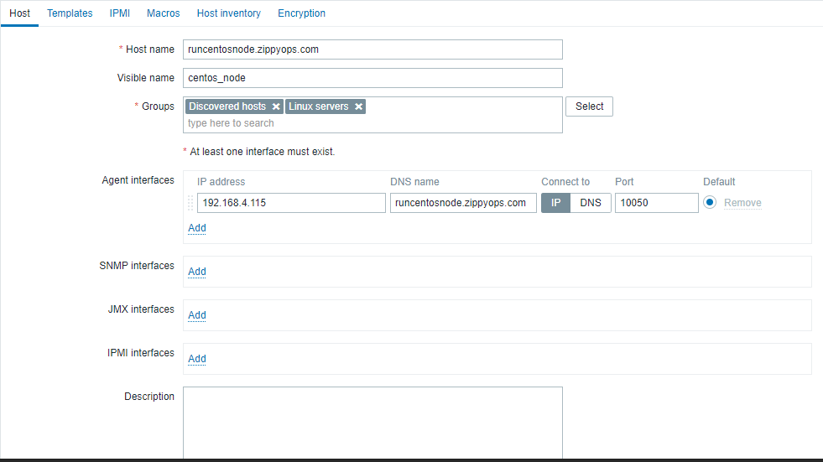

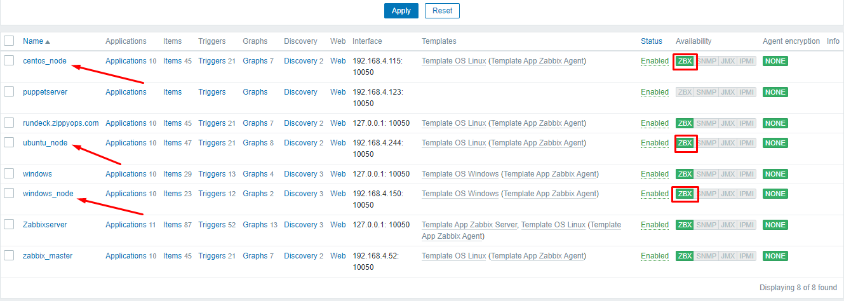

## 2.Create a Trigger for MEM-Usage:(Linux & Windows).

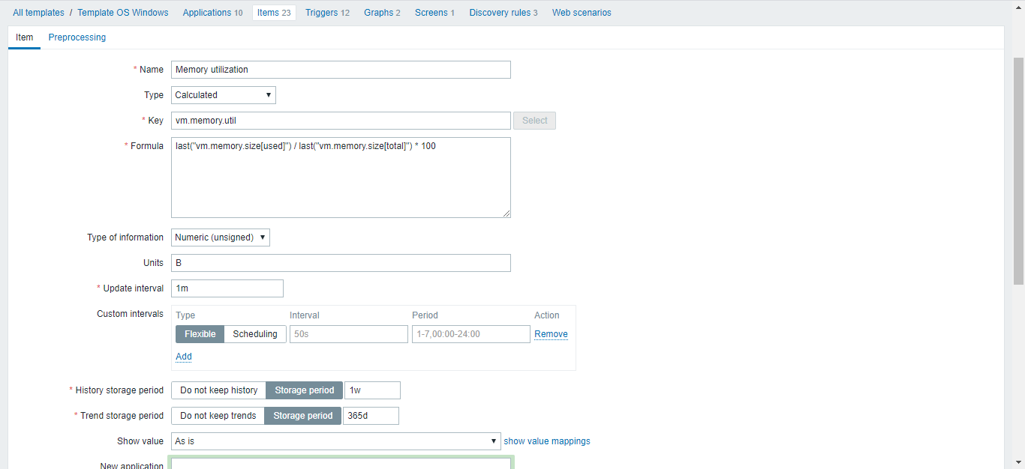

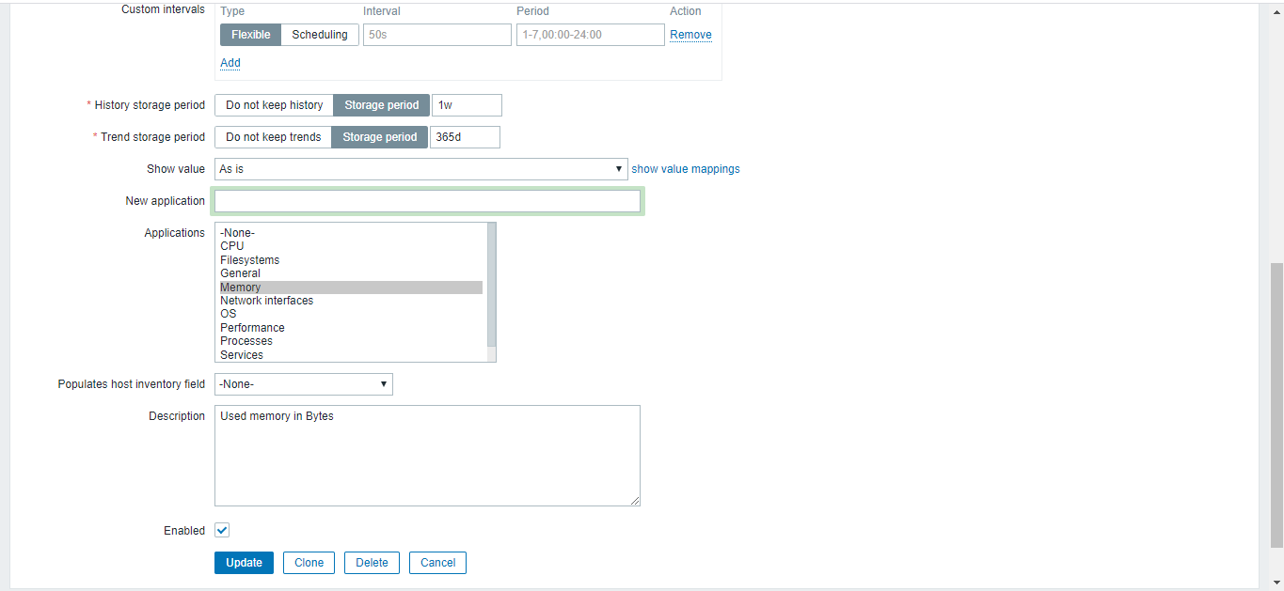

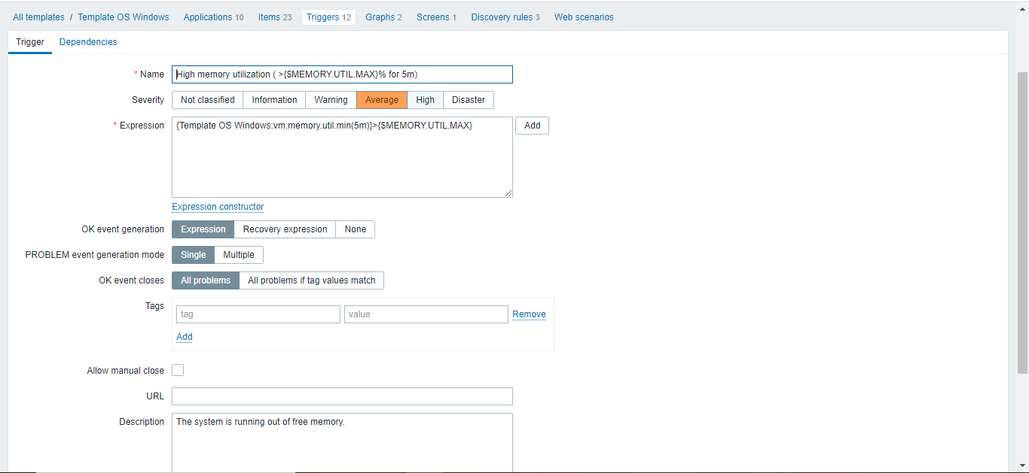

## 3.Create an Action for MEM-Usage and add condition:

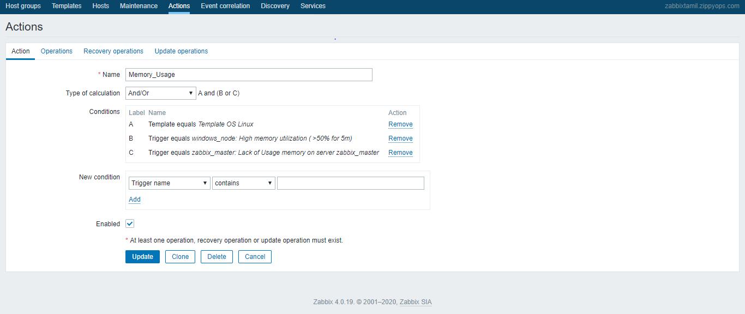

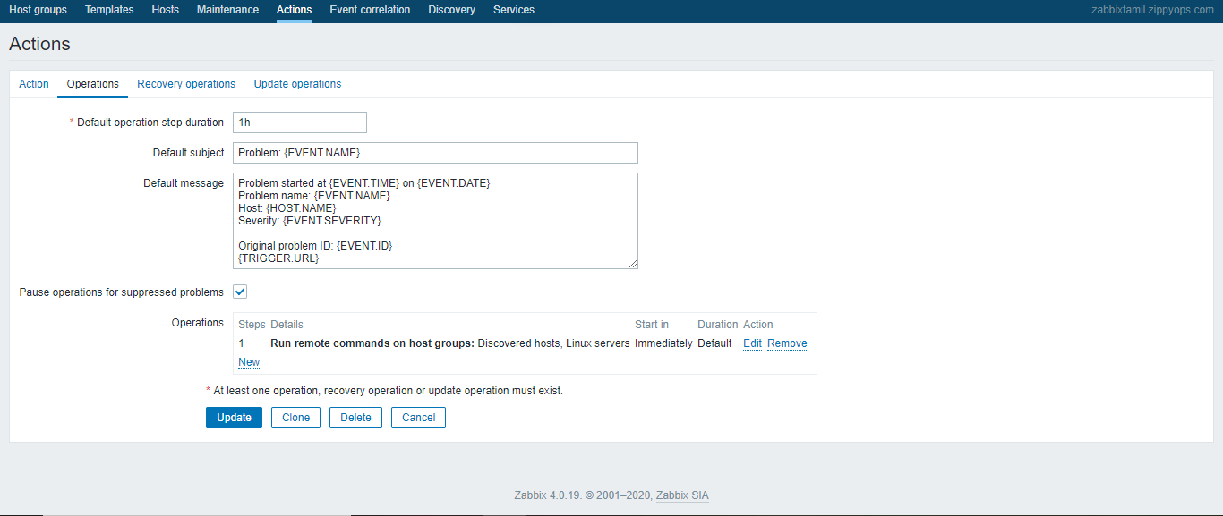

# 2.RUNDECK:

## 1.Create a Project for MEM-Usage:(LInux & Windows).

### **LINUX:**

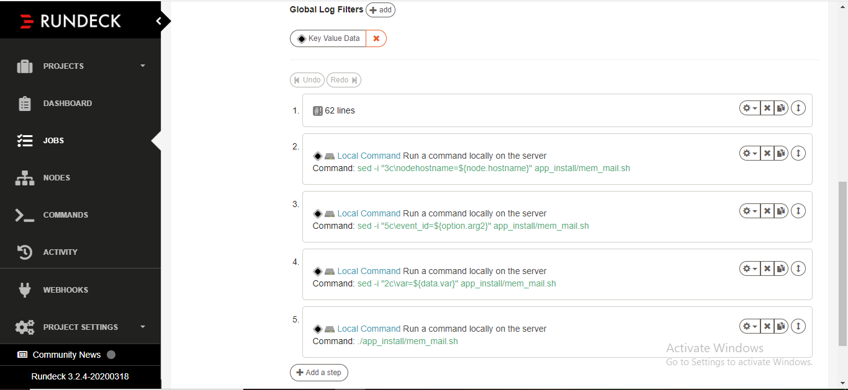

### **UBUNTU:**

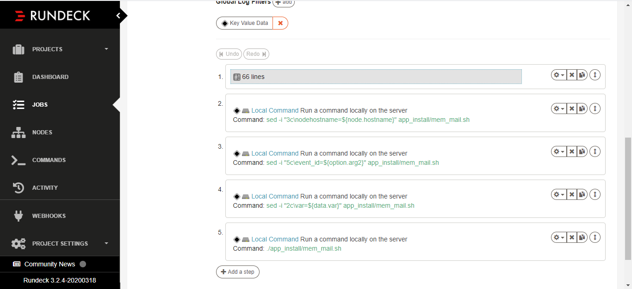

### **WINDOWS:**

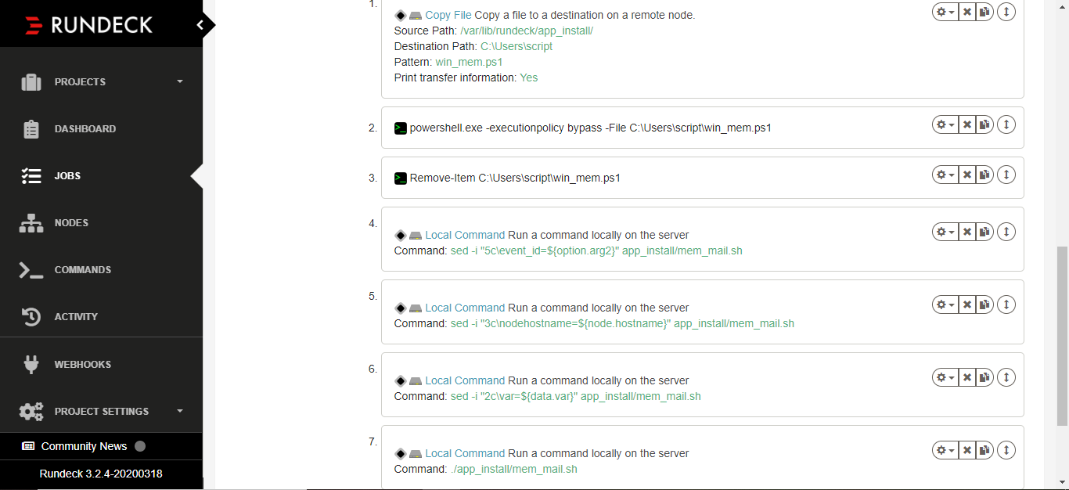

## LINUX SCRIPT:

nodeostype=@node.os-name@

nodehostname=@node.hostname@

TOPPROCESS=$(top -b -o %MEM -n 1 | sed 1,6d | sed -n 2p)

TOPPID=$(echo "$TOPPROCESS" | awk '{print $1}')

TOPNAME=$(echo "$TOPPROCESS" | awk '{print $12}')

echo "$nodeostype"

#echo "$nodehostname"

#echo "$server"

echo "$TOPPROCESS"

echo "$TOPPID"

echo "$TOPNAME"

if [ "$nodeostype" == "Centos" ]; then

echo "This is linux machine 192.168.4.115"

if [ "$TOPNAME" = "httpd" ]

then

systemctl restart httpd.service

var="$TOPNAME"

echo "$var"

echo "this is $TOPNAME"

elif [ "$TOPNAME" = "java" ]

then

systemctl restart jenkins

var="$TOPNAME"

echo "$var"

echo "this is $TOPNAME"

elif [ "$TOPNAME" = "mysqld" ]

then

systemctl restart mariadb

var="$TOPNAME"

echo "$var"

echo "this is $TOPNAME"

sleep 10

elif [ "$TOPNAME" = "python" ]

then

#kill -9 $TOPPID

var="$TOPNAME"

echo "$var"

echo "this is $TOPNAME"

elif [ "$TOPNAME" = "zabbix_agentd" ]

then

systemctl restart zabbix-agent

var="$TOPNAME"

echo "$var"

echo "this is $TOPNAME"

sleep 10

else

var="False"

echo "$var"

echo "Not for this $TOPNAME"

# java -jar /var/lib/rundeck/atlassian-cli-9.2.0/lib/acli-9.2.0.jar --server http://192.168.4.115:8080 --user "batch3zippyops" --password "zippyops" --action createIssue --project "CP" --type "Task" --summary "task2"

fi

fi

echo "var=$var"

## WINDOWS SCRIPT:

#!/bin/bash

$allProcesses=Get-Process | Sort-Object MEM -desc | Select-Object -first 1

Foreach ($process in $allProcesses){

#Write-host found service $service.Name found status $service.Status

echo "Process=$($process.Name), processID=$($process.Id), CPUPercentage=$($proce ss.CPU)"

}

if ($($process.CPU) -gt 30){

echo "YOUR process $($process.CPU)"

if ($($process.Name) -eq "zabbix_agentd"){

Restart-Service “Zabbix Agent”

echo "YOUR process $($process.Name)"

$var="$($process.Name)"

echo "var=$var"

}

if ($($process.Name) -eq "svchost"){

echo "YOUR process $($process.Name)"

$var="$($process.Name)"

echo "var=$var"

}

if ($($process.Name) -eq "System"){

echo "YOUR process $($process.Name)"

$var="$($process.Name)"

echo "var=$var"

}

if ($($process.Name) -eq "services"){

echo "YOUR process $($process.Name)"

$var="$($process.Name)"

echo "var=$var"

}

if ($($process.Name) -eq "powershell_ise"){

echo "YOUR process $($process.Name)"

$var="$($process.Name)"

echo "var=$var"

}else{

exit 0

}

}else{

echo "YOUR Process $($process.Name) = $($process.CPU)"

$var="False"

echo "var=$var"

}

echo "var=$var"

## MAIL SCRIPT:

#!/bin/bash

var=top

nodehostname=runcentosnode.zippyops.com

mail=<your-mail-id>

event_id=

if [ $nodehostname == runcentosnode.zippyops.com ]; then

if [ $var == ssh ]; then

echo "$var service running on $nodehostname" | mail -s "Memory Usage is high on Centos node" $mail

elif [ $var == httpd ]; then

echo "$var service running on $nodehostname" | mail -s "Memory Usage is high on Centos node" $mail

elif [ $var == python ]; then

java -jar /var/lib/rundeck/atlassian-cli-9.2.0/lib/acli-9.2.0.jar --server http://192.168.4.115:8080 --user "batch3zippyops" --password "zippyops" --action createIssue --project "MEM" --type "Task" --summary "task.$eventid" --field Issue_info --values "Unwanted services $var running on $nodehostname"

# echo "$var service running on $nodehostname" | mail -s "Memory Usage is high on Centos node" $mail

elif [ $var != False ]; then

echo " this JIRA ticket creation condition"

java -jar /var/lib/rundeck/atlassian-cli-9.2.0/lib/acli-9.2.0.jar --server http://192.168.4.115:8080 --user "batch3zippyops" --password "zippyops" --action createIssue --project "MEM" --type "Task" --summary "task.$eventid" --field Issue_info --values "Unwanted services $var running on $nodehostname"

else

echo "this is not $nodehostname"

exit 0

fi

elif [ $nodehostname == runubuntunode.zippyops.com ]; then

if [ $var == ssh ]; then

echo "$var service running on $nodehostname" | mail -s "Memory Usage is high on Ubuntu node" $mail

elif [ $var == java ]; then

echo "$var service running on $nodehostname" | mail -s "Memory Usage is high on Ubuntu node" $mail

elif [ $var == python ]; then

java -jar /var/lib/rundeck/atlassian-cli-9.2.0/lib/acli-9.2.0.jar --server http://192.168.4.115:8080 --user "batch3zippyops" --password "zippyops" --action createIssue --project "MEM" --type "Task" --summary "task.$eventid" --field Issue_info --values "Unwanted services $var running on $nodehostname"

# echo "$var service running on $nodehostname" | mail -s "Memory Usage is high on Ubuntu node" $mail

elif [ $var != False ]; then

echo " this JIRA ticket creation condition"

java -jar /var/lib/rundeck/atlassian-cli-9.2.0/lib/acli-9.2.0.jar --server http://192.168.4.115:8080 --user "batch3zippyops" --password "zippyops" --action createIssue --project "MEM" --type "Task" --summary "task.$eventid" --field Issue_info --values "Unwanted services $var running on $nodehostname"

else

echo "this is not $nodehostname"

exit 0

fi

elif [ $nodehostname == tamil-win-rest ]; then

if [ $var == System ]; then

echo "$var service running on $nodehostname" | mail -s ""Memory Usage is high on Windows node" $mail

elif [ $var == httpd ]; then

echo "$var service running on $nodehostname" | mail -s ""Memory Usage is high on Windows node" $mail

elif [ $var == python ]; then

java -jar /var/lib/rundeck/atlassian-cli-9.2.0/lib/acli-9.2.0.jar --server http://192.168.4.115:8080 --user "batch3zippyops" --password "zippyops" --action createIssue --project "MEM" --type "Task" --summary "task.$eventid" --field Issue_info --values "Unwanted services $var running on $nodehostname"

# echo "$var service running on $nodehostname" | mail -s ""Memory Usage is high on Windows node" $mail

elif [ $var != False ]; then

echo " this JIRA ticket creation condition"

java -jar /var/lib/rundeck/atlassian-cli-9.2.0/lib/acli-9.2.0.jar --server http://192.168.4.115:8080 --user "batch3zippyops" --password "zippyops" --action createIssue --project "MEM" --type "Task" --summary "task.$eventid" --field Issue_info --values "Unwanted services $var running on $nodehostname"

else

echo "this is not $nodehostname"

exit 0

fi

fi